**Answer 1:** At times the quickest method for finding a solution from your information is to play out an inquiry over your information utilizing **natural queries**. The Q&A highlight in Power BI allows you to investigate your information in the most natural sounding way for you utilizing normal language. Question and answer session is intelligent, even fun. Frequently, one inquiry prompts others as the representations uncover fascinating ways to seek after.

* Posing the inquiry is only the start. Go through your information, refining or growing your inquiry, revealing new data, focusing in on subtleties, or zooming out for a more extensive view.
* The experience is intuitive and quick, fueled by an in-memory stockpiling.
* Power BI Q&A is free and accessible to all clients.
* In Power BI Desktop, report creators can utilize Q&A to investigate information and make perceptions.
* In the Power BI help, everybody can investigate their information with Q&A.
* Our portable applications support Q&A as well, with the Q&A remote helper in iOS and the Q&A visual on Android gadgets.
* On the off chance that you have authorization to alter a dashboard or report, you can likewise stick your Q&A results.

**Answer 2: The Power** BI service engineering depends on two cluster **– the Web Front End (WFE) cluster and the Back-End cluster.** The WFE cluster deals with the underlying association and validation to the Power BI help, and when verified, the Back-End handles generally resulting client communications. Power BI uses Azure Active Directory (AAD) to store and oversee client characters, and deals with the capacity of information and metadata utilizing Azure BLOB and Azure SQL Database, individually.

**Power BI Architecture**

Each Power BI arrangement comprises of two cluster – a Web Front End (WFE) cluster, and a Back-End cluster.

The **WFE cluster deals** with the underlying association and confirmation process for Power BI, utilizing AAD to verify customers and give tokens to ensuing customer associations with the Power BI service. Power BI additionally utilizes the Azure Traffic Manager (ATM) to guide client traffic to the closest datacenter, dictated by the DNS record of the customer endeavoring to interface, for the verification cycle and to download static substance and documents. Power BI uses the Azure Content Delivery Network (CDN) to productively disseminate the essential static substance and records to clients dependent on topographical region.

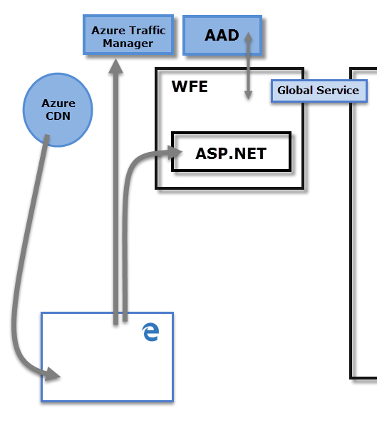

**Answer 3 :** The **Back-End cluster** is the means by which confirmed customers associate with the Power BI service. The Back-End cluster oversees perceptions, client dashboards, datasets, reports, information stockpiling, information associations, information invigorate, and different parts of interfacing with the Power BI assistance. The Gateway Role goes about as a passage between client demands and the Power BI assistance. Clients don't communicate straightforwardly with any jobs other than the Gateway Role. Purplish blue API Management will ultimately deal with the Gateway Role.

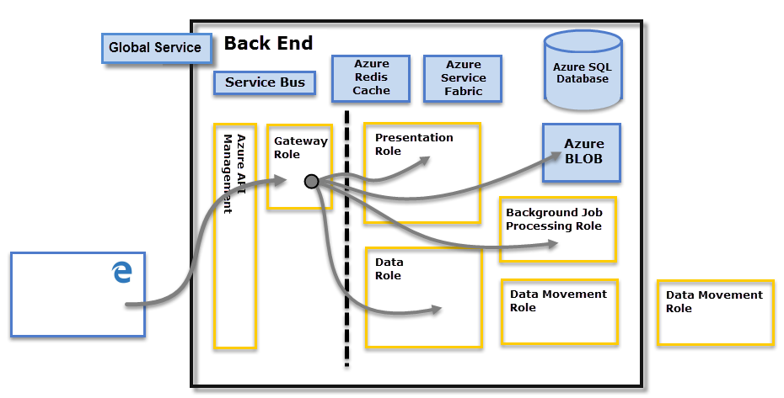

**Answer 4:** A WFE cluster comprises of an **ASP.NET** site running in the Azure App Service Environment. At the point when clients endeavor to interface with the Power BI help, the customer's DNS administration might speak with the Azure Traffic Manager to see as the most proper (generally closest) datacenter with a Power BI arrangement. For more data about this cycle, see Performance traffic-steering strategy for Azure Traffic Manager.

The WFE cluster relegated to the client deals with the login and confirmation arrangement (portrayed later in this article) and acquires an Azure AD access token once verification is fruitful. **The ASP.NET** part inside the WFE group parses the token to figure out which association the client has a place with, and afterward counsels the Power BI Global Service. The WFE determines to the program which back-end bunch houses the association's inhabitant. When a client is validated, resulting customer associations for client information happen with the back-end or Premium bunch straightforwardly, without the WFE being an intermediator for those solicitations.

Static assets, for example, *.js, *.css, and picture documents are generally put away on Azure Content Delivery Network (CDN) and recovered straight by the program. Note that Sovereign Government group arrangements are an exemption for this standard, and for consistence reasons will overlook the CDN and on second thought utilize a WFE bunch from a consistent area for facilitating static substance.

1. **Answer 5: Excel** is utilized to sort out information, change it and perform numerical tasks and computations. Then again**, Power BI** was imagined as a business knowledge and information representation device for organizations.
2. **Excel** has limits in how much information it can work with. Conversely, **Power BI** can deal with a lot bigger measures of information.
3. **Power BI** can interface with an enormous number of information sources, while Excel's network limit is restricted. Likewise, not at all like **Excel**, **Power BI** can be effortlessly utilized from cell phones.
4. **Power BI** has quicker handling than **Excel.**
5. **Power BI** dashboards are all the more outwardly engaging, intelligent and adaptable than those in **Excel.**
6. **Power BI** is a more amazing asset than **Excel** as far as examination between tables, reports or information documents.
7. **Power BI** is more easy to use and simple to use than **Excel**
8. **Answer 6: Data source:**
9. SQL Server database.
10. Access database.
11. SQL Server Analysis Services database.
12. Oracle database.
13. IBM Db2 database.
14. IBM Informix database (Beta)
15. IBM Netezza.
16. MySQL database.